**Sakila Tableau MySQL**

Question1:

Film categories by average rental amount (ranked) & – tabular & sql query

select FilmCategory, RentalAmount,

case

when @prerank = RentalAmount then @currank

when @prerank := RentalAmount then @currank := @currank + 1

end as Rank

from

(select c.name as FilmCategory, avg(p.amount) as RentalAmount

from Payment p

inner join rental r on r.rental_id=p.rental_id

inner join inventory i on i.inventory_id=r.inventory_id

inner join film f on f.film_id=i.film_id

inner join film_category fc on f.film_id=fc.film_id

inner join category c on c.category_id=fc.category_id

group by c.name order by avg(p.amount) desc) as t1,

(select @currank:=0,@prerank:=0) as t2;

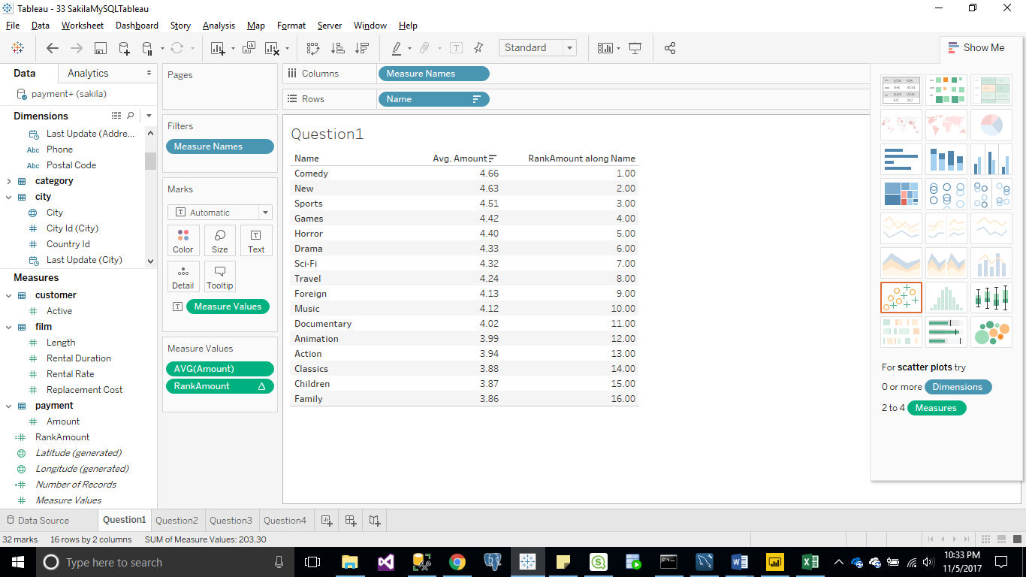

Question2:

List top 10 Customers (Last name, First Name) by rental amount (ranked)  for PG & PG-13 rated films – bar chart & sql query

select CustomerName, RentalAmount,

case

when @prerank = RentalAmount then @currank

when @prerank := RentalAmount then @currank := @currank + 1

end as Rank

from

(select concat(c.Last_name,',',c.first_name) as CustomerName, sum(p.amount) as RentalAmount

from payment p

inner join customer c on p.customer_id=c.customer_id

inner join rental r on r.rental_id=p.rental_id

inner join inventory i on i.inventory_id=r.inventory_id

inner join film f on f.film_id=i.film_id

where f.rating = 'PG' or f.rating= 'PG-13'

group by CustomerName order by RentalAmount desc) as t1,

(select @currank:=0,@prerank:=0) as t2 limit 10;

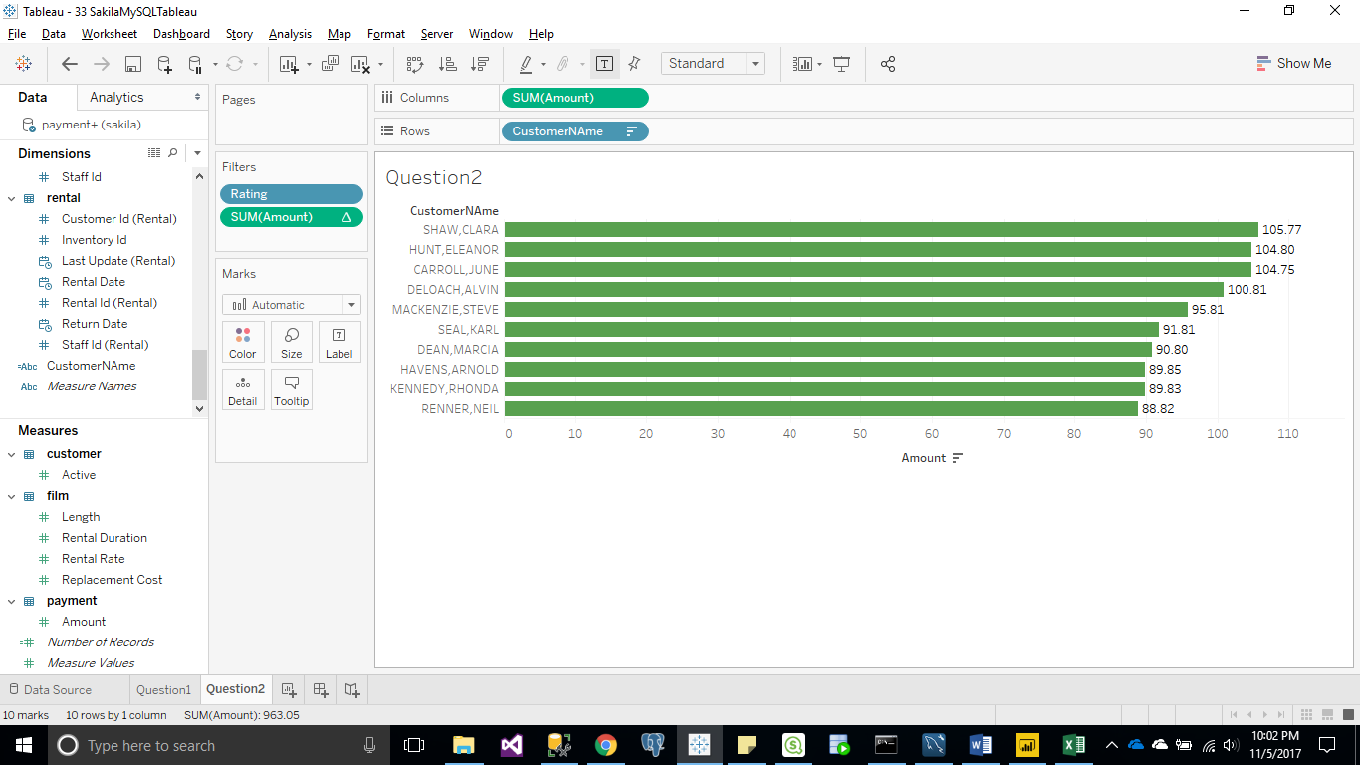

Question3:

List Films with the word “punk” in title with  rental amount and number of customers – tabluar & sql query

select f.title as FilmName, sum(p.amount) as RentalAmount, count(p.customer_id) as CustomerCount

from payment p

inner join rental r on r.rental_id=p.rental_id

inner join inventory i on i.inventory_id=r.inventory_id

inner join film f on f.film_id=i.film_id

where f.title like '%PUNK%'

group by FilmName order by RentalAmount desc;

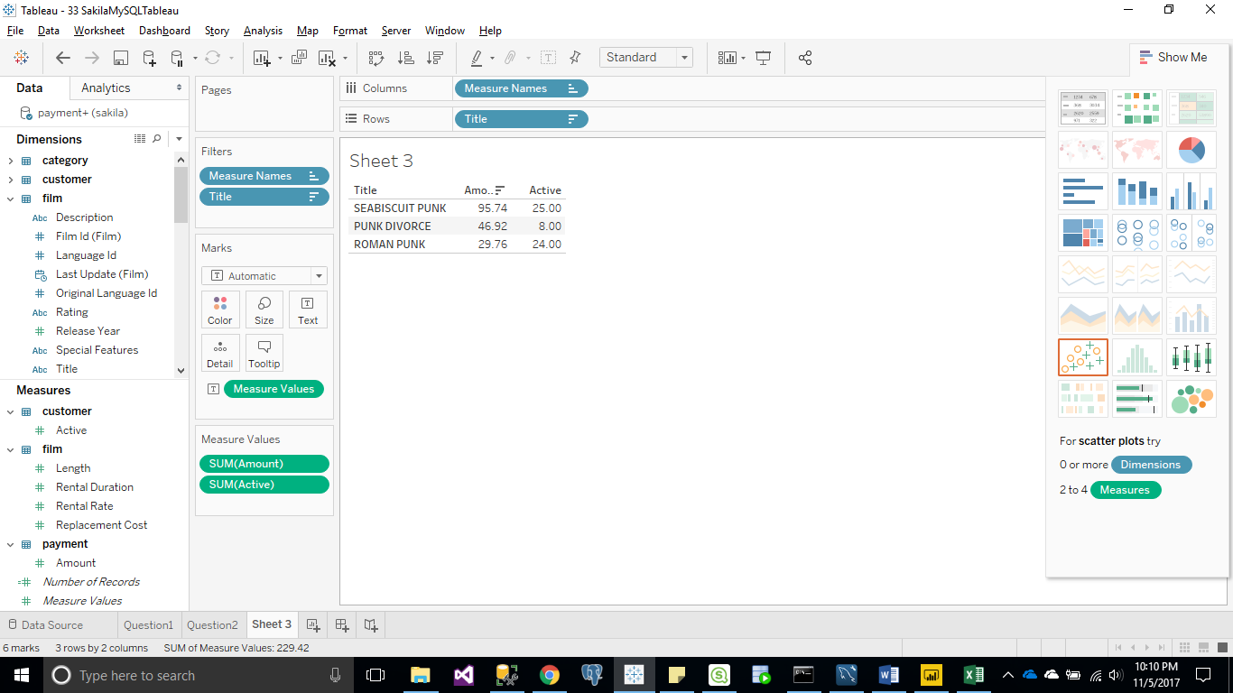

Question4:

Top 10 cities by rental amount – bar chart & sql query

select ci.city, sum(p.amount) as RentalAmount

from payment p

inner join customer cu on p.customer_id=cu.CUSTOMER_ID

inner join Address ad on cu.ADDRESS_ID=ad.ADDRESS_ID

inner join City ci on ad.CITY_ID=ci.CITY_ID

group by ci.city order by RentalAmount desc limit 10;

